Course 4

1. Create spring boot project using spring initializer

Create simple rest api to display welcome message.

With only one web starter

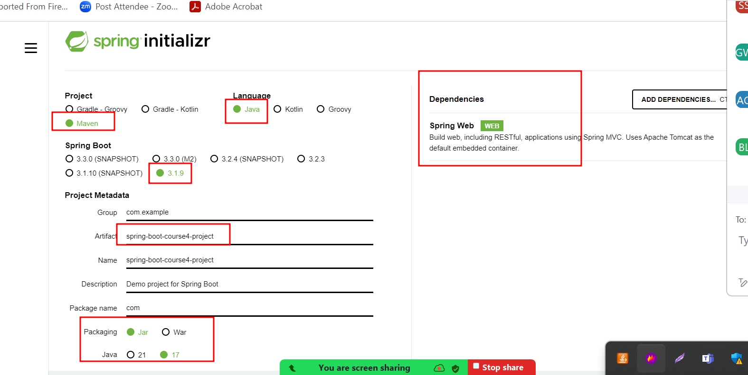

1. Create separate folder as course 4 assignment/projects
2. Extract the project and import in eclipse IDE.
3. Create simple rest api with get method to return simple message.
4. Now we need to create jar file for spring boot project.
5. If we need to custom name for jar file do the changes in pom.xml file

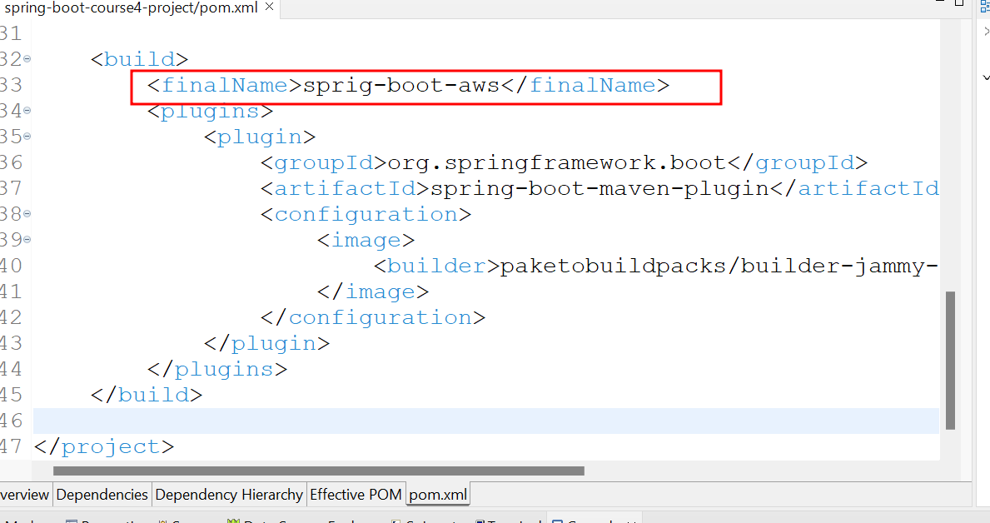

1. Using eclipse IDE you need to create jar file with help of run with maven install option.

Or

1. Using mvn package command you can create the jar file.
2. Now we need to create Dockerfile to create the image for spring boot application.
3. We create docker image in local machine and we will test the application.
4. Start the docker, create the image and run the container.

docker build -t my-spring-app . -f Dockerfile

docker images

docker run -d -p 9090:9090 my-spring-app

docker ps

check the application running or not.

1. Create the Jenkinsfile which is responsible to build the project using maven command, create docker image using docker file and run container.
2. Create Remote repository in git hub account and create token and push this project from local to remote repository.

First create remote repository

Then in local machine inside spring project open terminal

git init

git add .

git commit -m “done”

git remote add origin URLWithToken

git push -u origin HEAD

git remote add origin <https://token@github.com/Kaleakash/course4-caltech-batch-assignment.git>

1. After push the code in github account.
2. Now we need to login for AWS account and create EC2 instance.
3. In security group we need to open two port number 8080 for jenkin 9090 for Spring boot application.

Open all port number security group inbound rules.

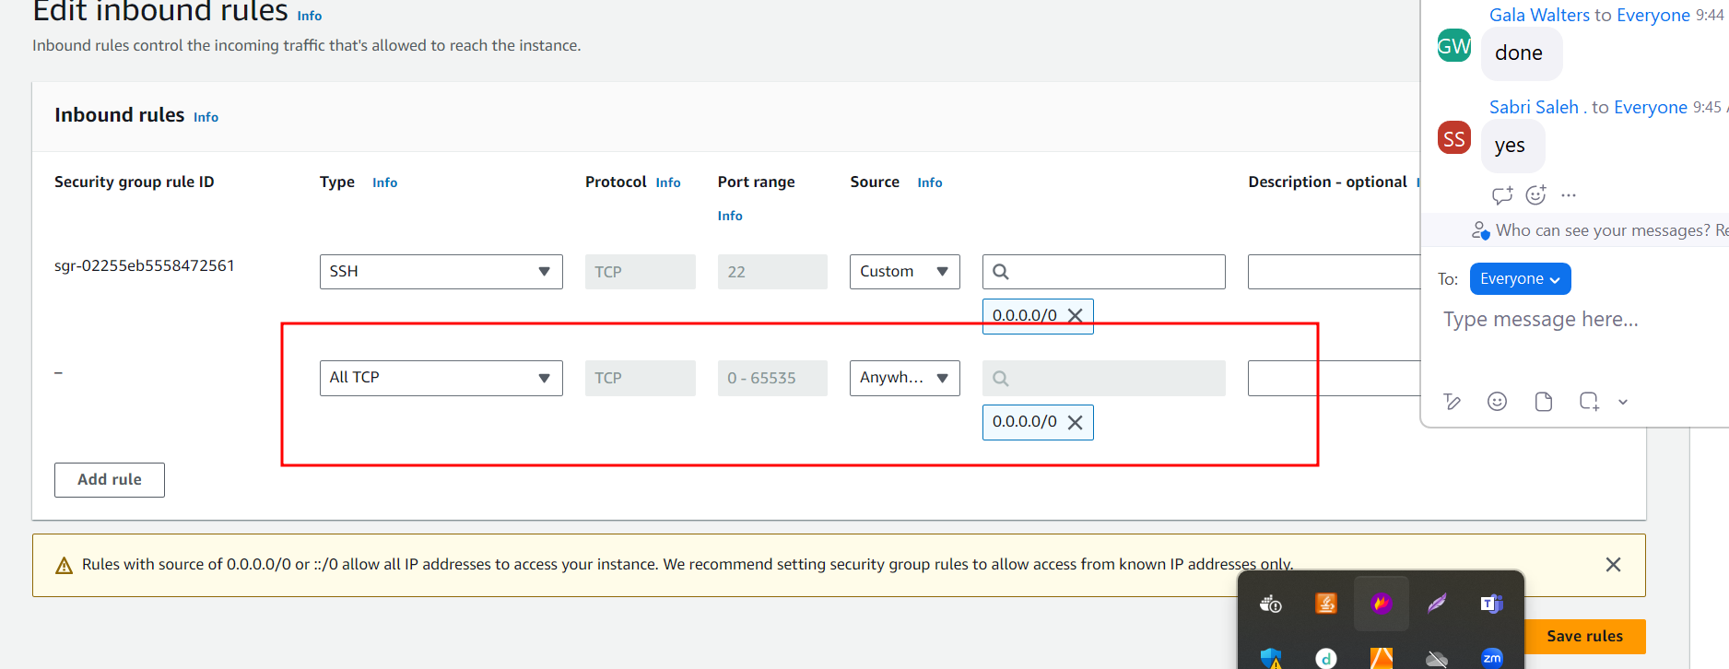

After install

Git

Java

Jenkin

Now using your EC2 instance public id address with port number 8080

We can open Jenkin software.

Below all command is use to install git, java, jenkin, docker and provide the permission

git install

--> sudo yum install git

java install

--> sudo yum install java

jenkin

-->sudo wget -O /etc/yum.repos.d/jenkins.repo https://pkg.jenkins.io/redhat/jenkins.repo

-->sudo rpm --import https://pkg.jenkins.io/redhat-stable/jenkins.io-2023.key

--> sudo yum install jenkins

--> sudo service jenkins start

--> sudo systemctl status jenkins

to find jenkin password

--> sudo cat /var/lib/jenkins/secrets/initialAdminPassword

docker install

sudo yum install docker

sudo service docker start

sudo docker info

----if you want to run docker and docker-compose in jenkin then please execute these command ---------------------

sudo usermod -a -G docker jenkins

sudo usermod -a -G docker ec2-user (ec2-user is user name of instance )

sudo chmod 777 /var/run/docker.sock

sudo service jenkins restart